DETECTION OF TUMOR IN BRAIN USING LEVEL SET ALGORITHM WITH DRAGONFLY OPTIMIZATION
MINI PROJECT REPORT (ACSE0459)
Bachelor of Technology
in
CSET (AI)

Submitted by:
Prateek Kumar Singh
2001331520083
Prashant Kumar
2001331520082
Vansh Chaudhary
2001331520117

Under the supervision of:
Dr. Kumud Saxena
H.O.D of Artificial Intelligence Dept.


Noida Institute of Engineering and Technology, Greater Noida
(An Autonomous Institute)
Affiliated to
DR. APJ ABDUL KALAM TECHNICAL UNIVERSITY, (UP)
May, 2022

Certificate

I hereby declare that the Project entitled “Detection of Tumor in Brain using Level Set Segmentation with Dragonfly Optimization” submitted to the CSET (AI)and Noida Institute of Technology, Greater Noida, U.P. in partial fulfillment for the award of the degree of BACHELOR OF TECHNOLOGY in session 2017-2021 is an authentic record of my own
work carried out under the guidance of Dr./Ms./Mr. “Dr. Kumud Saxena”
and that the project has not previously formed the basis for the award of any other degree.

Name: Prateek Kumar Singh
Roll No. 2001331520083
Name: Prashant Kumar
Roll No. 2001331520082
Name: Vansh Choudhary
Roll No.2001331520117

This is to certify that the above statement made by the above Candidate/Student is correct to the best of my knowledge.

Signature of Guide

ABSTRACT

Now a day’s tumor is second leading cause of cancer. Due to cancer large no of patients are in danger. The medical field needs fast, automated, efficient and reliable technique to detect tumor like brain tumor. Detection plays very important role in treatment. If proper detection of tumor is possible then doctors keep a patient out of danger. Various image processing techniques are used in this application. Using this application doctors provide proper treatment and save a number of
tumor patients. A tumor is nothing but excess cells growing in an uncontrolled manner.
Brain tumor cells grow in a way that they eventually take up all the nutrients meant for the healthy cells and tissues, which results in brain failure. Currently, doctors locate the position and the area of brain tumor by looking at the MR Images of the brain of the patient manually. This results in inaccurate detection of the tumor and is considered very time consuming. A tumor is a mass of tissue it grows out of control. We can use a Deep Learning architectures and Algorithms like Level Set Segmentation (the one’s we have used here). To predict if tumor is present or not in the image. If the tumor is present, it returns yes and a highlighted image of the place where tumor core is present, otherwise return no.
Brain tumor can be a deadly disease if it is not treated on before time being and may lead to a person`s death. That`s why accurate detection of tumor in brain is important. In this review paper we are trying to solve the same problem using level set algorithm, which is optimized using Dragonfly optimization algorithm supported by Mean Shift-clustering.

ACKNOWLEDGEMENTS

We are highly indebted to Dr. Kumud Saxena for her guidance and constant supervision as well as for providing necessary information regarding the project & also for their support in completing the project.

We would like to express my gratitude towards my parents & members of Noida Institute of Engineering and Technology for their kind cooperation and encouragement which help me in completion of this project.

We would like to express my special gratitude and thanks to industry persons for giving me such attention and time.

We thank and appreciations also go to our colleague in developing the project and people who have willingly helped me out with their abilities.

contents
Declaration ii
Certificate of Originality iii
Abstract iv
Acknowledgements v
List of Figures viii
CHAPTER 1: Introduction 1
CHAPTER 2:Literature Review 3
CHAPTER 3:Hardware And Software Requirements 4
CHAPTER 4:Necessary Packages Need to be Installed 5
CHAPTER 5:Using the Computer Vision (OpenCV-Python) 7
CHAPTER 6:Using the Artificial Neural Network (ANN) 8
CHAPTER 7:Methodology 10

CHAPTER 1

introduction

BRAIN TUMOR DETECTION SYSTEM
The human body is made up of many organs and brain is the most critical and vital organ of them all. One of the common reasons for dysfunction of brain is brain tumor. A tumor is nothing but excess cells growing in an uncontrolled manner. Brain tumor cells grow in a way that they eventually take up all the nutrients meant for the healthy cells and tissues, which results in brain failure. Currently, doctors locate the position and the area of brain tumor by looking at the MR Images of the brain of the patient manually. This results in inaccurate detection of the tumor and is considered very time consuming.
A Brain Cancer is very critical disease which causes deaths of many individuals. The brain tumor detection and classification system is available so that it can be diagnosed at early stages. Cancer classification is the most challenging tasks in clinical diagnosis.
This project deals with such a system, which uses computer, based procedures to detect tumor blocks and classify the type of tumor using Level Set Algorithm on MRI images of different patients.
Different types of image processing techniques like image segmentation, image enhancement and feature extraction are used for the tumor detection in brain the MRI images of the tumor-affected patients.
Detecting Brain tumor using Image Processing techniques it involves the four stages is Input Stage ,Image Pre-Processing, Feature Extraction, and Output Generation Stages.
Image processing and Level set Algorithm are used to improve the performance for the detecting and classifying brain tumor in MRI images.

OVERVIEW OF BIOLOGICAL TERMS USED
Brain Anatomy:
Main part in human nervous system is human brain. It is located inside human skull and it is surrounded by the Cerebrospinal This specialized organ is responsible for every thought, every feeling, and the vast majority of our actions. Its unique (and complex) three-dimensional architecture plays an important role in deciding upon and issuing those important commands. In this section we describe the structure of the brain for understanding the basic things. In the below figure , one can easily understand the structure of the brain and understand it’s anatomy.
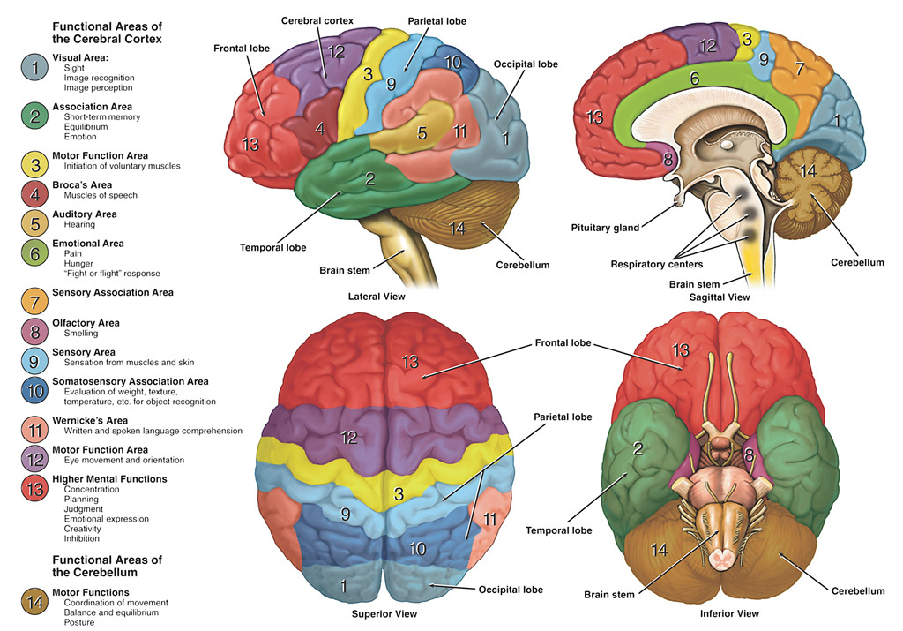
Fig.1: (Sagittal View) Basic Structure of human brain
The above highlighted parts in the image are the different viewing angles of the human brain. Over the past few hundred years, scientists have learned that the brain has dedicated regions responsible for specific tasks like understanding and producing speech or processing visual and spatial information. Each part of the brain’s intricate configuration works together to govern sensation and perception, information processing, and the initiation of a wide variety of behaviors—and helps us make sense of the world around us.

Brain Tumor: Overview

Before understanding Brain tumor, let’s first understand about what is tumor. Tumor is a collection of unwanted mass in any part of the body. They can occur in Brain, Lungs, Liver, Breast, and prostate grands, etc.

The brain tumors are classified into mainly two types:
- Primary brain tumor
- Secondary brain tumor

Primary Brain Tumor:
The Primary Brain Tumor are also known as Benign or low-grade tumor. Low grade tumor is not cancerous tumor and can’t spread to other parts of the body. It originates from non-neuronal brain cells called astrocytes. Basically, primary tumors are less aggressive but these tumors have much pressure on the brain and because of that, brain stops working properly. The Primary Brain Tumor are also divided into different types – Gliomas, Meningiomas, Acoustic neuromas, Pituitary adenomas, Medulloblastomas, Germ cell Tumor, Craniopharyngiomas.

Secondary Brain Tumor:
The Secondary Brain Tumor are also known as Malignant or high-grade tumor. High grade tumor is cancerous, so they can spread to other regions of the body or they may start from another body and eventually reach brain. The secondary tumors are more aggressive and quicker to spread into other tissue. Secondary brain tumor originates through other part of the body. The Secondary Brain Tumor are also divided into multiple types - lung cancer, breast cancer, kidney cancer, melanoma skin cancer, bowel (colorectal) cancer.

MRI (Magnetic Resonance Imaging):
Magnetic resonance imaging (MRI) is a medical imaging technique that uses a magnetic field and computer-generated radio waves to create detailed images of the organs and tissues in your body. Most MRI machines are large, tube-shaped magnets. When you lie inside an MRI machine, the magnetic field temporarily realigns water molecules in your body. Radio waves cause these aligned atoms to produce faint signals, which are used to create cross-sectional MRI images — like slices in a loaf of bread. MRI is a noninvasive way for your doctor to examine your organs, tissues and skeletal system. It produces high-resolution images of the inside of the body that help diagnose a variety of problems. There are different images of MRI for mapping tumor induced Change including T1 weighted, T2 weighted and FLAIR (Fluid attenuated inversion recovery) weighted shown in figure below.

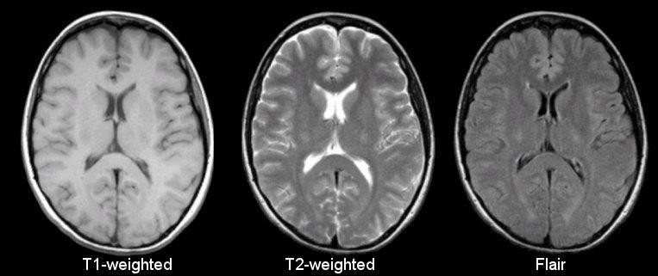
T1-Weighted T2-Weighted Flair Images
T1, T2 and Flair image

Why Prefer MRI Scans Over Other Scans:

CT (computed tomography) and MRI (magnetic resonance imaging) are both used to diagnose and stage cancer. Many people do not know the difference between the two methods or why one might be selected over the other. Because CTs use ionizing radiation, they could damage DNA and may very slightly raise the risk of developing cancer. The Food & Drug Administration estimates that the extra risk of any one person developing a fatal cancer from a typical CT procedure is about 1 in 2,000. MRIs do not use ionizing radiation, so there is no issue of raising cancer risk. But they take much longer to complete than CTs. MRIs require the person to lie still within a closed space for about 20 to 40 minutes. This can affect some people with claustrophobia, and the procedure is noisy, which is why we provide ear protection. This is why MRI is preferred over CT Scan or Ultrasound Scans as it provides detailed information without harming the tumor or other cells in the brain .

CHAPTER 2

LITERATURE REVIEW

Paper-1: Image Analysis for MRI Based Brain Tumor Detection and Feature Extraction Using Biologically Inspired BWT and SVM
- Publication Year: 6 March 2017
- Author: Nilesh Bhaskarrao Bahadure, Arun Kumar Ray, and Har Pal Thethi
- Journal Name: Hindawi International Journal of Biomedical Imaging
- Summary: In this paper using MR images of the brain, we segmented brain tissues into normal tissues such as white matter, gray matter, cerebrospinal fluid (background), and tumor-infected tissues. We used pre-processing to improve the signal-to-noise ratio and to eliminate the effect of unwanted noise. We can used the skull stripping algorithm its based on threshold technique for improve the skull stripping performance.

Paper-2: A Survey on Brain Tumor Detection Using Image Processing Techniques

Publication Year: 2017
- Author: Luxit Kapoor, Sanjeev Thakur
- Journal Name: IEEE 7th International Conference on Cloud Computing, Data Science & Engineering
- Summary: This paper surveys the various techniques that are part of Medical Image Processing and are prominently used in discovering brain tumors from MRI Images. Based on that research this Paper was written listing the various techniques in use. A brief description of each technique is also provided. Also of All the various steps involved in the process of detecting Tumors, Segmentation is the most significant.

Paper-3: Identification of Brain Tumor using Image Processing Techniques

- Publication Year: 11 September 2017
- Author: Praveen Gamage
- Journal Name: Research gate
- Summary: This paper survey of Identifying brain tumors through MRI images can be categorized into four different sections; pre-processing, image segmentation, Feature extraction and image classification.

Paper-4: Review of Brain Tumor Detection from MRI Images

Publication Year: 2016
- Author: Deepa, Akansha Singh
- Journal Name: IEEE International Conference on Computing for Sustainable Global Development
- Summary: In this paper, some of the recent research work done on the Brain tumor detection and segmentation is reviewed. Different Techniques used by various researchers to detect the brain Tumor from the MRI images are described. By this review we found that automation of brain tumor detection and Segmentation from the MRI images is one of the most active Research areas.

Paper-5: An efficient Brain Tumor Detection from MRI Images using Entropy Measures
- Publication Year: December 23-25, 2016
- Author: Devendra Somwanshi , Ashutosh Kumar, Pratima Sharma, Deepika Joshi
- Journal Name: IEEE International Conference on Recent Advances and Innovations in Engineering
- Summary: In this paper, we have investigated the different Entropy functions for tumor segmentation and its detection from various MRI images. The different threshold values are obtained depend on the particular definition of the entropy. The threshold values are dependent on the different entropy function which in turn affects the segmented results.

Paper-6: Classification of Brain Tumors from MRI Images Using a convolutional Neural Network
- Publication Year: 15 March 2020
- Author: Milica M. Badza and Marko C. Barjaktarovi
- Journal Name: Applied Science , MDPI
- Summary: In this paper a new CNN architecture was used for brain tumor classification which of three types. The developed network is simpler than already-existing pre-trained networks, and it was trained on T1-weighted contrast-enhanced magnetic resonance images.

Paper-7: Brain Image Data Repair and Diagnosis Technology Based on Deep Learning
- Publication Year: March 2021
- Author: Aryan Sagar Methil
- Journal Name: Researchgate Publications
- Summary: Tumor detection method based on directional feature saliency model in MRI brain images is introduced in this paper. Firstly, in order to overcome the influence of skull, we use mathematical morphology to remove the skull region of MRI brain image. Then, the saliency detection of directional features is used to extract the contrast of the tumor region in the image. Finally, the segmentation results are optimized by noise elimination, segmentation and a series of morphological operations.

Paper-8: Brain Tumor Classification Using Convolutional Neural Networks
- Publication Year: 13 September 2018
- Author: J. Seetha and S. Selvakumar Raja
- Journal Name: Biomedical & Pharmacology Journal
- Summary: The human brain is modeled by using design and implementation of neural network. The neural network is mainly used for vector quantization, approximation, data clustering, pattern matching, optimization functions and classification techniques. Convolution filter is used in the first layer, then the sensitivity of filter is reduced by smoothing the convolution filter (i.e.,) subsampling, then training Loss layer is added at the end to give a feedback to neural network, improving the training to much greater extent.

Paper-9: Dragonfly Algorithm with Opposition-Based Learning for Multilevel Thresholding Color Image Segmentation
- Publication Year: 27 May 2019
- Author: Xiaoli Bao, Heming Jia and Chunbo Lang
- Journal Name: Symmetry Journals , MDPI
- Summary: The proposed algorithm has a faster convergence speed and more balanced exploration compared with the original DA. In order to clearly demonstrate the outstanding performance of the OBLDA, the proposed method was compared with seven state-of-the-art meta-heuristic algorithms, through experiments on 10 test images. The optimal threshold values are calculated by the maximization of between-class variance and Kapur’s entropy. Meanwhile, some indicators, including peak signal to noise ratio (PSNR), feature similarity index (FSIM), structure similarity index (SSIM), the average fitness values, standard deviation (STD), and computation time are used as evaluation criteria in the experiments.

Paper-10: Fractional Distance Regularized Level Set Evolution with its application to image segmentation
- Publication Year: May 6, 2020
- Author: Meng Li ,Yi Zhan and Yongxin
- Journal Name: Institute of Electrical and Electronics Engineers (IEEE) Acess Journal
- Summary: In order to avoid the irregularities during the level set evolution, a fractional distance regularized variational model was for image segmentation. We first define a fractional distance regularization term which punishes the deviation of the level set function (LSF) and the signed distance function. To facilitate the calculation of fractional derivatives and their conjugates, we designed their covering templates. Finally, a numerical solution to the minimization of the energy functional is obtained from these discrete forms and covering templates.

CHAPTER 3

Hardware And Software Requirements

This is the list of the hardware and software requirements which leads to our project to the successful mission completion.
- 16 GB RAM
- 8 Core i5 Processor
- Intel Iris GPU
- Python Idle console
- VS Code Editor

CHAPTER 4

Necessary Packages Need to be Installed

There are a few python packages which need to be installed to perform our machine and deep learning concept in our project. The list is given below: -
- NumPy
NumPy is a library for the Python programming language, adding support for large, multi-dimensional arrays and matrices, along with a large collection of high-level mathematical functions to operate on these arrays. The ancestor of NumPy, Numeric, was originally created by Jim Hugunin with contributions from several other developers. In 2005, Travis Oliphant created NumPy by incorporating features of the competing Numarray into Numeric, with extensive modifications.
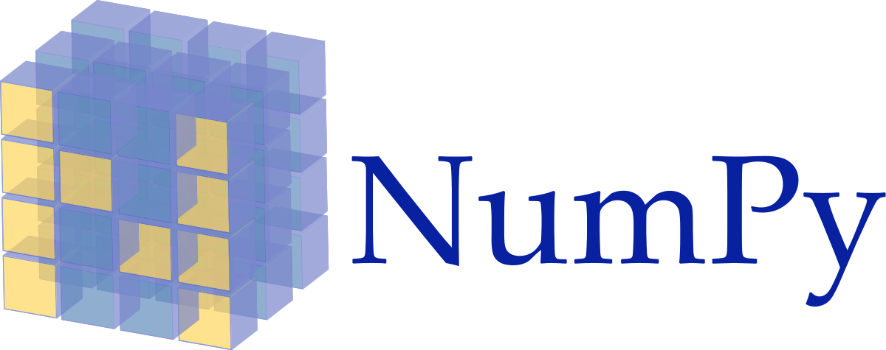
Fig. 1

- OpenCV

OpenCV (Open Source Computer Vision Library) is a library of programming functions mainly aimed at real-time computer vision. Originally developed by Intel, it was later supported by Willow Garage then Itseez (which was later acquired by Intel). The library is cross-platform and free for use under the open-source Apache 2 License. Starting with 2011, OpenCV features GPU acceleration for real-time operations.


- Level Set:
This python code implements a new level set formulation, called distance regularized level set evolution (DRLSE), proposed by Chunming Li et al's in the paper "Distance Regularized Level Set Evolution and its Application to Image Segmentation", IEEE Trans. Image Processing, vol. 19 (12), 2010. This package only implements an edge-based active contour model as one application of DRLSE.

- Sklearn
Scikit-learn is a free software machine learning library for the Python programming language. It features various classification, regression and clustering algorithms including support vector machines, random forests, gradient boosting, k-means and DBSCAN, and is designed to interoperate with the Python numerical and scientific libraries NumPy and SciPy.


- Matplotlib
Matplotlib is a plotting library for the Python programming language and its numerical mathematics extension NumPy. It provides an object-oriented API for embedding plots into applications using general-purpose GUI toolkits like Tkinter, wxPython, Qt, or GTK+.

=
Tensorflow:
TensorFlow is a free and open-source software library for machine learning and artificial intelligence. It can be used across a range of tasks but has a particular focus on training and inference of deep neural networks.
TensorFlow was developed by the Google Brain team for internal Google use in research and production. The initial version was released under the Apache License 2.0 in 2015. Google released the updated version of TensorFlow, named TensorFlow 2.0, in September 2019.



CHAPTER 5

Using the Computer Vision (OpenCV-Python)
Computer vision is an interdisciplinary scientific field that deals with how computers can gain high-level understanding from digital images or videos. From the perspective of engineering, it seeks to understand and automate tasks that the human visual system can do.
USE OF A COMPUTER VISION IN OUR PROJECT
Computer vision tasks include methods for acquiring, processing, analyzing and understanding digital images, and extraction of high-dimensional data from the real world in order to produce numerical or symbolic information, e.g. in the forms of decisions.
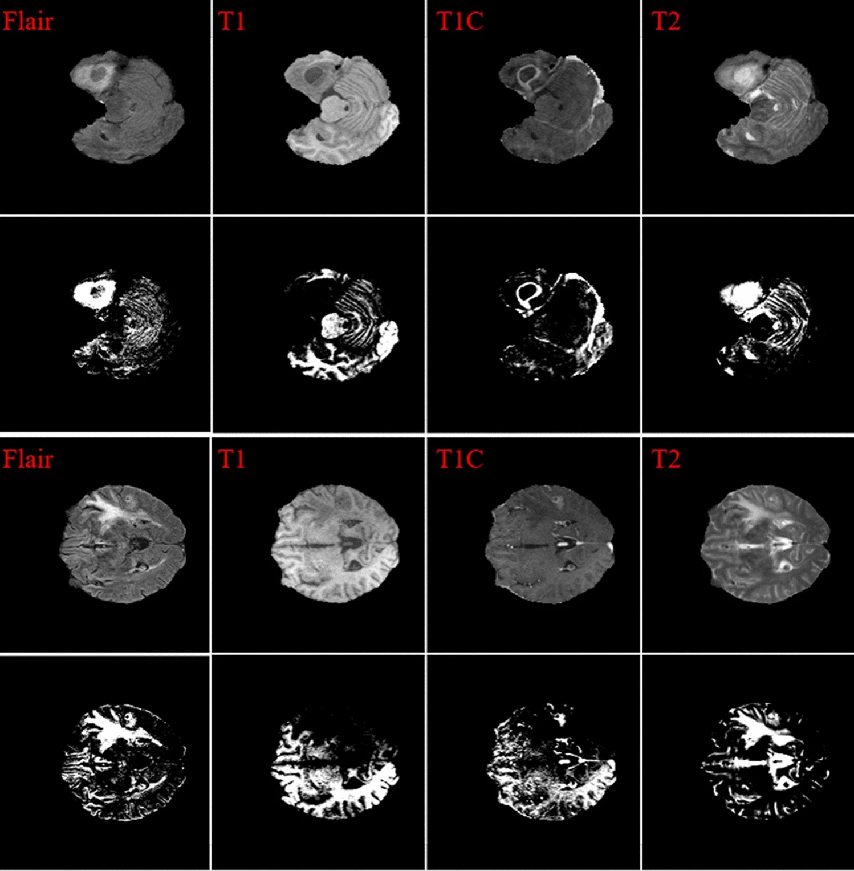

Fig 2: Some Brain Tumor Datasets

CHAPTER 6

Level set SEGMENTATION METHOD

Level-set methods (LSM) are a conceptual framework for using level sets as a tool for numerical analysis of surfaces and shapes. The advantage of the level-set model is that one can perform numerical computations involving curves and surfaces on a fixed Cartesian grid without having to parameterize these objects (this is called the Eulerian approach. Also, the level-set method makes it very easy to follow shapes that change topology, for example, when a shape splits in two, develops holes, or the reverse of these operations. All these make the level-set method a great tool for modeling time-varying objects, like inflation of an airbag, or a drop of oil floating in water.
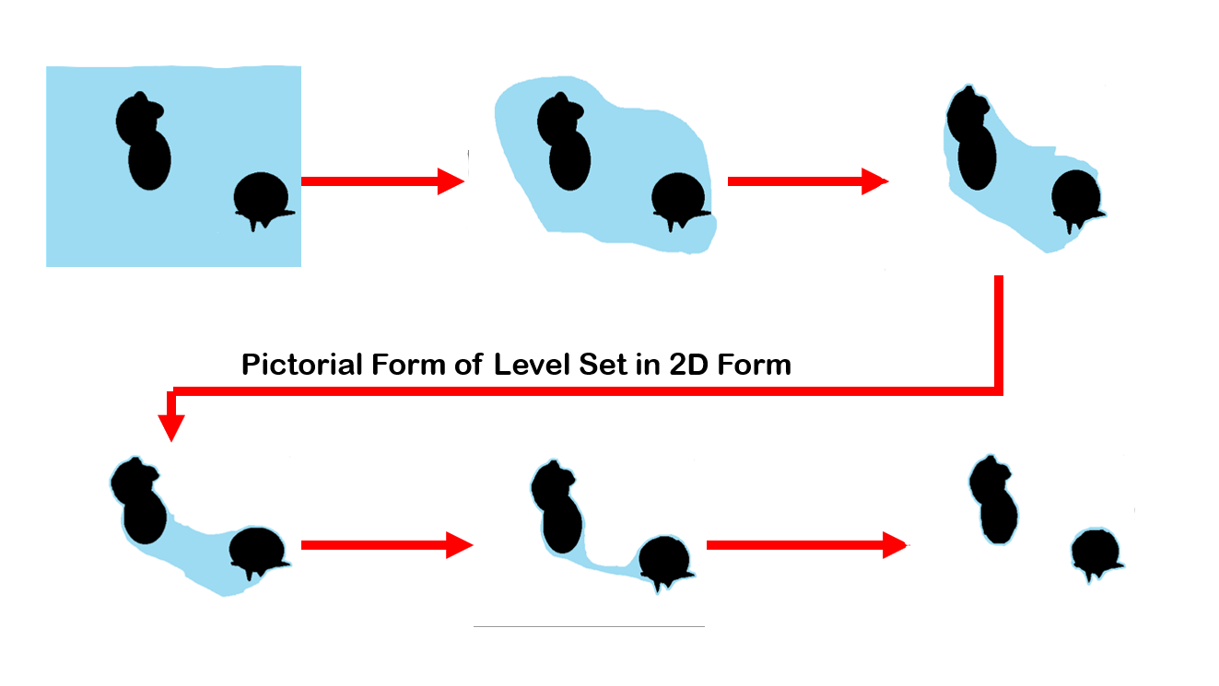
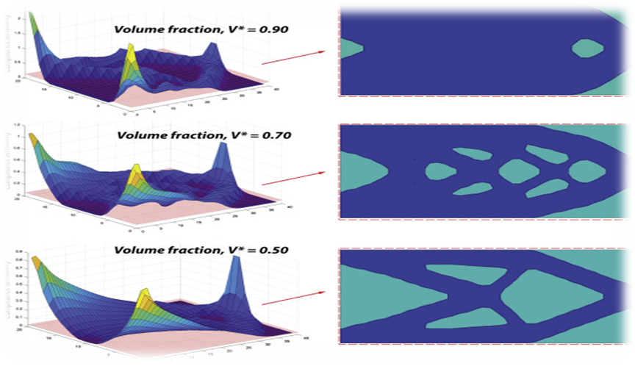
: change 1 : change 2 :change 3

DA (Dragonfly algorithm) Method
The main inspiration of the Dragonfly Algorithm (DA) algorithm proposed in 2015 originates from static and dynamic swarming behaviors. These two swarming behaviors are very similar to the two main phases of optimization using meta-heuristics: exploration and exploitation. Dragonflies create sub swarms and fly over different areas in a static swarm, which is the main objective of the exploration phase. In the static swarm, however, dragonflies fly in bigger swarms and along one direction, which is favorable in the exploitation phase. Five primitive principles of using swarming algorithms. …………………/
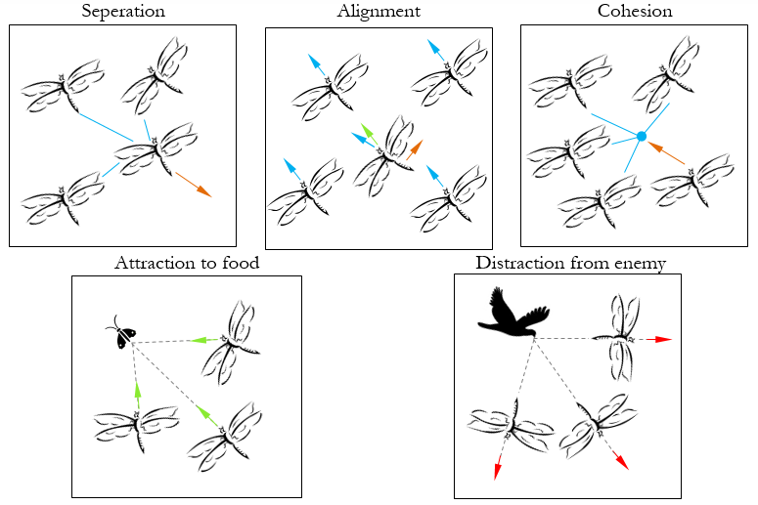

Five concepts allow us to simulate the behaviors of dragonflies in both dynamic and static swarms.

CHAPTER 7

METHODOLOGY

We started our project creation in the ‘VSCode Editor’ Application. And used python as the language for this project. Firstly, we tried to collect data of MRI scans , and found them on Kaggle and Oasis.

DATASET (Kaggle URL): - We downloaded the dataset in our local machine manually. From the below URL:
https://www.kaggle.com/datasets/navoneel/brain-mri-images-for-brain-tumor-detection
This Dataset is created by Navoneel Chakrabarty, it was updated with latest patient details 2yrs ago.

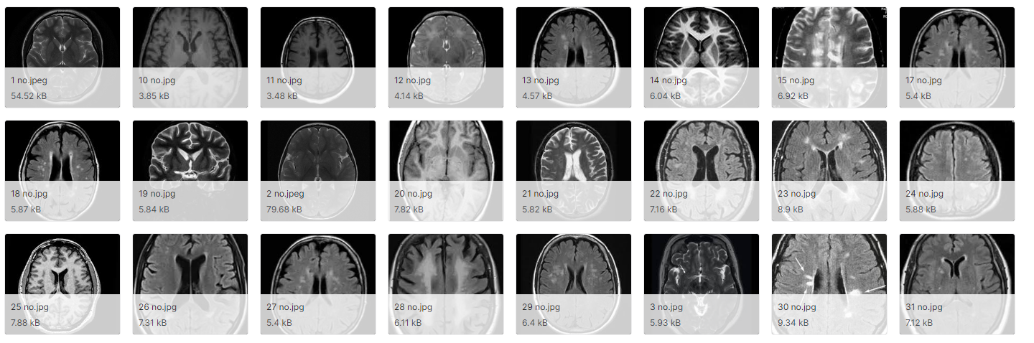

Fig. 7 Example of images from the Dataset

THE IMPLEMENTATION PROCESS:
We started and completed our code in a python file named “Tumor_detection.py”. We will discuss all the implementations via step-by-step approach.
- Step1: Data Acquition (Data Input Stage): -
In this we will be importing modules required and as well as downloading the Kaggle dataset from this URL. (https://www.kaggle.com/datasets/navoneel/brain-mri-images-for-brain-tumor-detection )

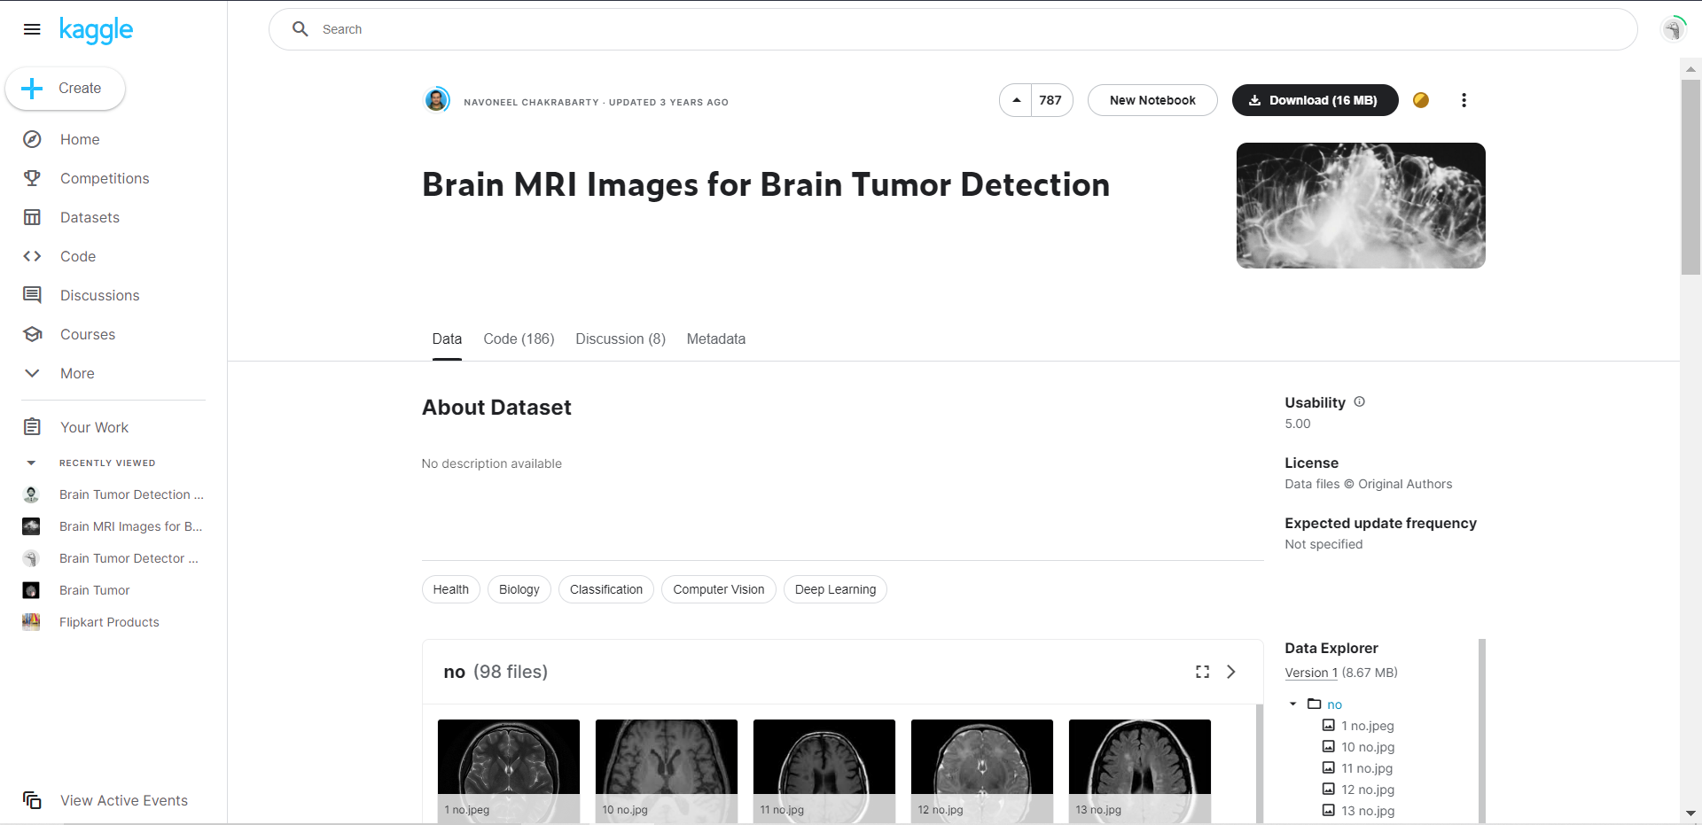

- Step 2:(Pre-Processing Stage)
This stage involves three stages :- (i) Denoising ,(ii) Morphological Operations , (iii) Threshold Segmentation.
- DENOISING:
We will be using Mean Filter method from Linear filter. It is a simple sliding-window filter that replaces the center pixel value in the kernel window with the average (mean) of all the pixel values in that kernel window.
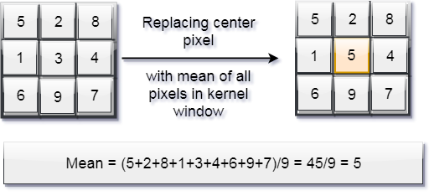

- MORPHOLOGICAL OPRATIONS (i.e., Image Masking):
Masking is used in Image Processing to output the Region of Interest, or simply the part of the image that we are interested in. We tend to use bitwise operations for masking as it allows us to discard the parts of the image that we do not need.
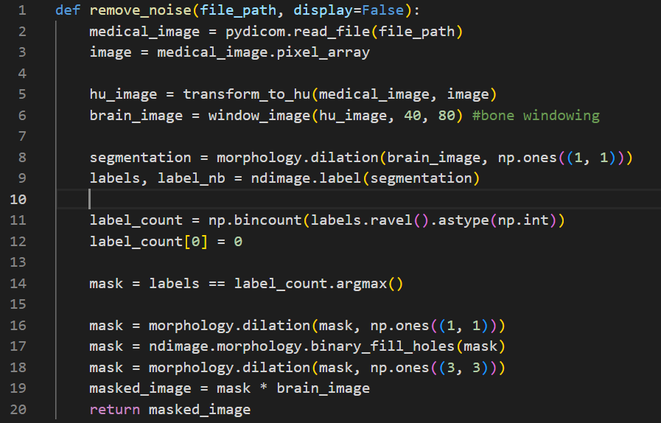
The above code masks and removes the skull part of the brain for further image analysing.
THRESHOLD SEGMENTATION:
Thresholding is a technique in OpenCV, which is the assignment of pixel values in relation to the threshold value provided. In thresholding, each pixel value is compared with the threshold value. If the pixel value is smaller than the threshold, it is set to 0, otherwise, it is set to a maximum value (generally 255). Thresholding is a very popular segmentation technique, used for separating an object considered as a foreground from its background. A threshold is a value which has two regions on its either side i.e. below the threshold or above the threshold. In Computer Vision, this technique of thresholding is done on grayscale images. So initially, the image has to be converted in grayscale color space.
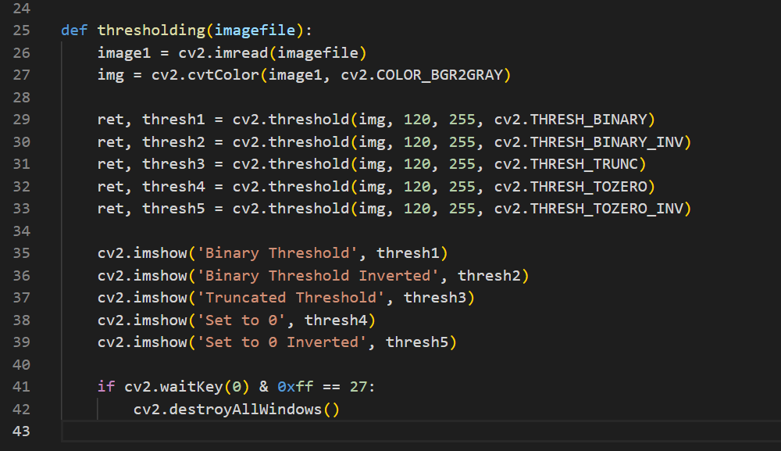

- Step 3: Extraction Stage:
Before coming to this stage the image as under gone many process like Denoising, Masking,Thresholding segmentation. The before part was just the peeling part of the image and now after this the image will under go cooking to result in the required output. The processes involved in this stage are: (i) Two-step Dragonfly Algorithm (ii) Level-Set Segmentation

TWO-STEP DRAGONFLY ALGORITHM: It is a swarm intelligence optimization algorithm, that was proposed by Mirjalli in 2015. It is inspired by two unique clusters orientations found in nature :Foraging group (static grp) , Migratory group
(dynamic-grp) .
The DA algorithm is developed based on the framework of the Particle Swarm Optimization (PSO) algorithm, so there are two main vectors: step vector and position vector. These vectors store the movement directions/speed and position of dragonflies, respectively.As DA is highly effective in finding optiman sollutions which are converging nature.
Clustering is a powerful tool in machine learning systems, it uses predefined similarity criterion for grouping unlabeled group of data objects or clusters [39,40]. The clustering problem can be formulated as an optimization problem as follow: given a set S={s1,s2, s3… sn} is a set of n objects and Tn∗m is a data matrix consisting of n rows and m columns where n represents the number of objects of a dataset, and m represents the number of attributes (features) or dimensions of a given dataset. The i-th data object xi={i=1,2,3, …n} is defined using a real-valued m-dimensional vector where each object xij denotes the j-th feature (j=1,2,3,…m) of the i-th object (i=1,2,3,…n). The objective of the clustering algorithm is to create a set of partition Z={z1, z2, …zk} for the given data matrix Tn×m and satisfying the following conditions:

∀_{i}≠j_{zi}∩zj=∅ ------------(1)
Uk_{i}=1z_{i}=x --------------(2)
∀iz_{i}=∅

In our model, to accelerate the convergence rate and preserve the stability during exploration and exploitation, a two-step DA algorithm is used to improve it for clustering problems using the k-means algorithm .The main steps of the DA clustering algorithm are shown in Algorithm 1. Herein, to handle randomization of the selection of the center of the mass of the neighborhood within the DA algorithm, k-means is used to generate accurate centers.
Algorithm 1: Two-step Dragonfly Clustering.
Input: D dataset contains MRI brain images
Output: Best solution of final cluster center (Cbest,j) j=1,2,3,4
Begin
Initialization phase
Initialize the position of dragonfly population X_{i} (i = 1 2, ..., n).
Initialize step vectors Δ X_{i}
For i=1:SN /* SN is the total number of food sources (number of clusters) */
Initialize the food source within the boundary of given dataset in random order;
Evaluate the better potions of food sources by applying the k-means algorithm / *Algorithm 2*/
Send the dragonflies to the food sources; / * Computed centers */
End For
Dragonfly algorithm Phase
Iteration = 0;
Do While (the end condition is not satisfied)
For i = 1:n
Calculate the fitness of each dragonfly
Update the food source and enemy
Update w, s, a, c, f, and e
Calculate S, A, C, F, and E using Equations (4) to (8)
Update neighboring radius
If (a dragonfly has at least one neighboring dragonfly)
Update step vector (ΔX) using Equation (9)
Update position vector X using Equation (10)
Else
Update position vector using Equation (11)
End if
Check and correct the new positions based on the boundaries of variables
End For
For i=1:SN
Compute the probability. /* Calculate the probability for each one */
End For
For i=1:SN
If (rand ( ) < Pi) /* Pi denotes the probability associated with ith food source */
Calculate the new fitness of the new food source using Equation (14);
Select the best food source by using a greedy selection between the old and new food source;
Else
i=i+1;
End If
End For
End While
Output: Final clusters‘ centers.
End

Initialization stage: The K-means algorithm (see Algorithm 2) is used to find the initial food sources (center of the mass of the neighborhood). Herein, four clusters representing background (RB), gray matter (RG), white matter (RGW), and tumor (RGTC) as stated in [41] are identified. Each point is then assigned to the nearest centroid. In this paper, the Euclidean distance is used as a measure to the proximity which used to assign objects to the nearest centroids. The clusters are created by assigning each object to the suitable cluster based on the proximity measure, the centroids then updated based on the average of the object proximity measures in each cluster. The reassigning process and centroids updating are repeated until there is no change in each cluster’s objects .
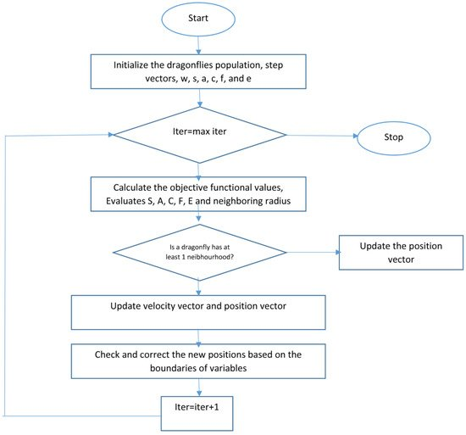
WorkFlow of DA Segmentation

LEVEL SET SEGMENTATION:
Level set (LS) techniques are powerful tools for modelling time varying objects, by using level set techniques it is not difficult to follow topological changes in the object shape. They use deformable models with active contour energy minimization techniques without parametrizing the surface to find a solution for the minimal distance curves problem. LS methods are controlled by curvature-dependent speeds of moving curves or fronts [21,45,46]. The initial position of the contour is always a key challenge in some LS methods while solving segmentation problems. The contour can move inward or outward and its initial position determines the target for segmentation. In segmenting images with poorly defined boundaries, some methods replace the initial contour with a region-based active contour and the re-initialization step has been eliminated by including a term in the Partial Differential Equation (PDE) that penalizes the deviation of level set function from a contour based signed distance function. Different level set methods differ either in how to form an initial contour or the energy functional to be minimized or some combination of both. There are still key challenges in using level set in image segmentation and there is no general level set method that can solve segmentation problem for all applications. In our case, the deformable model initialization uses the cluster centers that are computed using the previous phase for each slice as the initial placement for final tumor segmentation.
Level set segmentation techniques are based on two main stages: first, the insertion of the interface as the zero level set of a higher dimensional function, and, second, the interface’s speed to this higher dimensional level set function. The evolvement of the contour or surface is managed by a level set equation. The solution to which this partial differential equation tends to is determined iteratively by updating φ at each time interval. The level set method is a numerical algorithm that gradually tracks the motion of a curve (in 2D slices) implicitly by embedding a propagating interface Γ as the zero level set φ(X, t)=0 of a higher dimensional function φ(X, t), where X=(x,y), and t represents time. The level set function φ, defined over the image space, is a surface which is positive inside the region Ω, negative outside Ω, and zero on the interfaces between Ω and other regions. The general form of the level set equation is.
Ω(t) = {χ(x0, t, t0), x0 ∈ Ω(t0)}

Algorithm 3: Level set segmentation.
1: Insert initial contour points using two-step DA clustering output (ROI indexes).
2: Construct a signed distance function.
3: Calculate feature image using Gaussian filter and gradient.
4: Obtain the curve’s narrow band.
5: Obtain curvature and use gradient descent to minimize energy.
6: Evolve the curve.
7: Repeat step number two and stop after obtaining the segmented region.

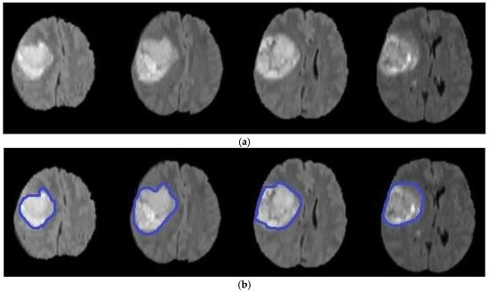

- Step-4: Experimental Results
As for the experimental result the result comes out as just the tumor part which was detected from from the patient’s MRI scan images .
Here below is an example:
The Original image given as input:
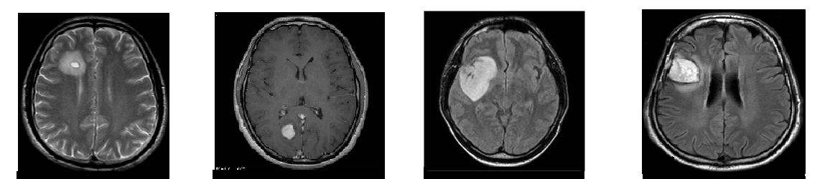
The result of these image from the above processing :

Here the returned images are just the tumor detected regions , with the same dimentions of the original image they are then overlapped to produce an image that shows the proper tumor region.

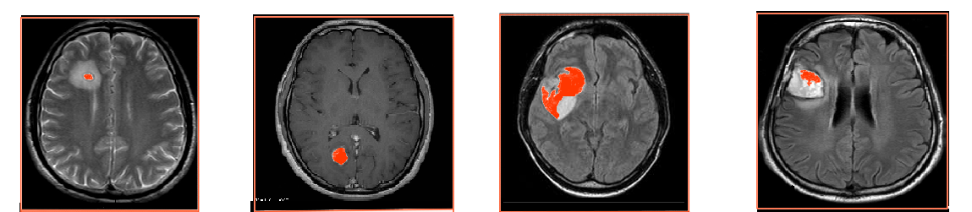

Conclution:
The results confirm the superiority of the suggested model as it increases the accuracy by 5.27% compared with the SVM-based brain segmentation algorithm. One possible explanation of this result is that using a two-step DA approach enhances segmentation accuracy as it detects an accurate initial contour rather than choosing it randomly or less accurately, as is done in the compared methods. The search mechanism of DA is maintained by the utilization of the information obtained from k-means. In other words, the connection between k-means and DA helps to increase accuracy and decrease the error rate. Figure 8 shows a sample of segmentation results.

